<!--This file created 11/24/99 2:14 PM by Claris Home Page version 3.0-->
Inside the Atom
A WebQuest for High School Chemistry
Designed by:
Bob Bartelt
Bobbo1137@aol.com
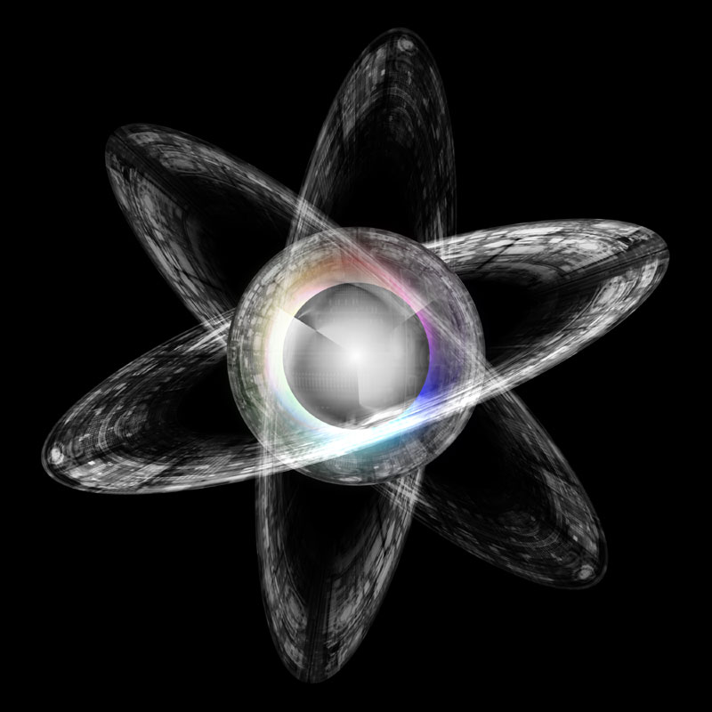
Introduction | Task | Process | Evaluation | Conclusion | Credits | Teacher Info
Introduction
Since antiquity, man has wondered, “what is the universe made of?” Ancient philosophers were able to intuit the idea of the atom thousands of years before the enlightenment with virtually no assistance from what would today be considered “science”. Today our conception of the atom is limited more by the frailty of the human mind than by anything else. The quest for the atom is not a quest to discover atoms-atoms are everywhere. They quest for the atom is the quest to understand the atom, what its made of, how it’s held together. Your search will lead you into the depths of history, to the time when the very idea democracy was first introduced. The journey then stalls for nearly 2000 years where you will pick it up when the ages old ideas of magic and religious superstitions finally gave way to science and reason. From the brilliant minds of ancient Greek philosophers to the massive particle accelerator of today, you will be led on a journey to unearth a mystery, millennia old, and still alive and well today; and in the end you will discover the wonder and the beauty of…
The Atom, the Building Block of the Universe
The Task
As a young college student, I found it impossible to decide between my two great intellectual passions: Chemistry and History. After majoring in both, I undertook the only career that would force me to continue to learn about both, teaching. Your assignment today is to blend my two great loves into one coherent and organized presentation that will demonstrate your mastery of both history and science.
Your task is to explain the evolution of atomic theory and show both me and the rest of the class how we today have come to understand the fascinating world of the atom. Atoms are far too small to be seen by the naked eye, and as a result, scientist and philosophers have been forced to create theories and conduct experiments to attempt to “crack” into the mystery of the atom. There have been several major bench mark discoveries/theories in the development of modern atomic theory. It is your job to create a PowerPoint presentation that illuminates the shadowy and imperceptible world of the atom.
Your PowerPoint presentation should provide information about all of the following models/theories of the atom:
- Atomism and the earth, fire, wind, water model
- The solid sphere model
- The plum pudding model
- The planetary or nuclear model
- The orbital model
- The electron cloud or quantum mechanical model
Your PowerPoint presentation should have an attention grabbing introduction that convinces the audience that your presentation will be fun and exciting.
For each of these models you need to provide the following information:
- The person or people most responsible for the development of the model.
- A description of the experiment that was conducted and a summary of the data that was produced that led to the development of the model. (you are exempt from doing this for the model #1) Be sure to include the date when the model was first presented.
- A graphical representation of what that model of the atom would look like if we were able to actually see atoms. (this image may be created by you or taken from the internet, be sure to sight where the image came from if you use the internet)
You are also expected to have a coherent conclusion that ties all of the different models together and leaves the audience with a feeling of closure and comprehension.

Web Links

General Information/Timelines
- Wikipedia
- Brief timeline (this should get you oriented to some of the major dates in the development of atomic theory and science in general)
- Another Brief timeline
- In depth timeline (Lots of information)
- Visual timeline (LOTS of great picture, and a good-albeit brief-explanation of the history of the universe)

In Depth Examination of Individual models
- John Dalton
- Plum Pudding
- Planetary or Nuclear Model
- The Orbital Model
- If you read all of it, it will blow your mind
- The math behind the planetary model
- Excellent Graphic for the orbital model
- Quantum Model
- Find “Quantum Atom” on this page (If you read all of it, you should understand. This web page would have changed to world if it had been around two hundred years ago)

Evaluation
You will be assessed on four different criteria:
Objectives | Beginning  1 | Developing  2 | Accomplished  3 | Exemplary  4 | Score
The presentation addressed all three requirements for every model set forth in “The Task” | Glaring omissions and evidence of little to no effort. | Information is present, but shows little understand and effort. | Information is present but lacks coherence or evidence of genuine understanding. | Information is present and shows a genuine understanding of the material, not just mindless memorization. | __
The PowerPoint | The presentation is simple and lacks graphics. Shows little effort to make the presentation enjoyable for the class | Use of graphics and other effects is minimal. | Uses graphics and other effects. These graphics are sometimes used inappropriately or unnecessarily. | Uses graphics and other effects appropriately to enhance the presentation of the PowerPoint. | __
The Presentation | The presentation was poor and showed no evidence of previous rehearsal. | The presenter is knowledgeable, but shows little familiarity with the PowerPoint. | The presenter is knowledgeable and is familiar with the PowerPoint. The presentation fails to simulate and maintain interest. | The presenter is knowledgeable and is familiar with the PowerPoint. The presentation is also interesting. | __
Organisation | The presentation and power point are out of sync and are difficult to follow. | The presentation and power point often failed to coincide. | The presentation and power point work well together, but the information is scattered and hard to follow | The presentation and power point work together well and the information is logically presented and easy to understand | __

Conclusion
The quest for the atom had been a long and arduous one, and it still continues to this day. In your research you may have notices that the structure of the atom is more or less settled, but the structure of the nucleus is still uncertain. The massive particle accelerators of today are looking deeper into the atom than enlightenment scientist could have dreamed. We still need young scientists to continue searching the depths of the nucleus for particles still smaller than protons, neutrons, and electron. It’s possible that one of you could be the one who proves or disproves string theory.
What’s string theory?

Last updated in December 2006. Based on a template from The WebQuest Page

